**Listening test - section 02 - Practise test 01**

**Questions 11 – 14**

Choose the correct letter, **A**, **B** or **C**.

**Matthews Island Holidays**

**11**   According to the speaker, the company

**A**   has been in business for longer than most of its competitors.

**B**   arranges holidays to more destinations than its competitors.

**C**   has more customers than its competitors.

**12**   Where can customers meet the tour manager before travelling to the Isle of Man?

**A**   Liverpool

**B**   Heysham

**C**   Luton

**13**   How many lunches are included in the price of the holiday?

**A**   three

**B**   four

**C**   five

**14**   Customers have to pay extra for

**A**   guaranteeing themselves a larger room.

**B**   booking at short notice.

**C**   transferring to another date.

**Questions 15-20**

Complete the table below.

Write **ONE WORD AND/OR A NUMBER** for each answer.

|  |  |  |
| --- | --- | --- |
| **Timetable for Isle of Man holiday** | | |
|  | **Activity** | **Notes** |
| Day 1 | Arrive | Introduction by manager  Hotel dining room has view of the **15**………… |
| Day 2 | Tynwald Exhibition and Peel | Tynwald may have been founded in **16**………… not 979. |
| Day 3 | Trip to Snaefell | Travel along promenade in a tram; train to Laxey; train to the **17**…………. of Snaefell |
| Day 4 | Free day | Company provides a **18**…………. for local transport and heritage sites. |
| Day 5 | Take the **19**…………. railway train from Douglas to Port Erin | Free time, then coach to Castletown – former **20**………… has old castle. |
| Day 6 | Leave | Leave the island by ferry or plane |

**Answers**

11   A

12   B

13   A

14   C

15   river

16   1422

17   top

18   pass

19   steam

20   capital

**Listening test - section 02 - Practise test 02**

Questions 11-20

Questions 11-13

Choose the correct letter, **A, B** or **C.**

**Winridge Forest Railway Park**

**11** Simon's idea for a theme park came from

**A**  his childhood hobby. **B** his interest in landscape design.

**C** his visit to another park.

**12** When they started, the family decided to open the park only when

**A** the weather was expected to be good. **B** the children weren't at school.

**C** there were fewer farming commitments.

**13** Since opening, the park has had

**A** 50,000 visitors. **B** 1,000,000 visitors. **C** 1,500,000 visitors.

What is currently the main area of work of each of the following people?

Choose **FIVE** answers from the box and write the correct letter **A-H** next to questions 14-18

**Area of work**

**A** advertising

**B** animal care

**C** building

**D** educational links

**E** engine maintenance

**F** food and drink

**G** sales

**H** staffing

**People**

**14** Simon (the speaker) ­­____________

**15**  Liz ____________

**16** Sarah ____________

**17**  Duncan ____________

**18**  Judith ____________

Questions 19 and 20

Complete the table below.

Write **ONE WORD AND/OR NUMBERS** for each answer.

|  |  |  |  |
| --- | --- | --- | --- |
| **Feature** | **Size** | **Biggest challenge** | **Target age group** |
| Railway | 1.2 km | Making tunnels |  |
| Go-Kart arena | 19 __________ m² | Removing mounds on the track | 20 __________ year-olds |

**Answers**

11. C  
12. A  
13. C  
14. E  
15. H  
16. F  
17. C  
18. G  
19. 120  
20. 5-12

**Listening test - section 02 - Practise test 03**

Questions 11-20

Questions **11-16**

What change has been made to each part of the theatre?

Choose SIX answers from the box and write the correct letter, **A-G,** next to questions **11-16**.

**RIVENDEN CITY THEATRE**

**Part of the theatre**

**11** box office ……………

**12** shop ……………

**13** ordinary scats ……………

**14** seats for wheelchair users ……………

**15** lifts. ……………

**16** dressing rooms ……………

**A** doubled in number

**B** given separate entrance

**C** reduced in number

**D** increased in size

**E** replaced

**F** strengthened

**G** temporarily closed

**Questions 17-20**

Complete the table below.

Write **NO MORE THAN TWO WORDS ANDIOR A NUMBER** for each answer.

|  |  |  |  |  |
| --- | --- | --- | --- | --- |
| **Play** | **Dates** | **Starting time** | **Tickets available** | **Price** |
| Royal Hunt of the Sun | October  13th to 17 | 18 ………. P.m. | for 19 ………… and …………… | 20 € |

Answers

11. B  
12. G  
13. C  
14. A  
15. E  
16. D  
17.   (October (the)) 19th  
18.   7  
19.   Monday Thursday  
20.   18

**Listening test - section 02 - Practise test 04**

Questions 11-14

Choose the correct letter, **A, B** or **C**

**11** Stevenson’s was founded in

**A** 1923 **B** 1924 **C** 1926

**12** Originally, Stevenson’s manufactured goods for

**A** the healthcare industry **B** the automotive industry **C** the machine tools industry

**13** What does the speaker say about the company premises?

**A** The company has recently moved

**B** The company has no plans to move

**C** The company is going to move shortly

**14** The programme for the work experience group includes

**A** time to do research **B** meetings with a teacher **C** talks by staff

Questions 15-20

Label the map below.

Write the correct letter, **A-J**, next to Questions **15-20**.

**Plan of stevenson’s site**

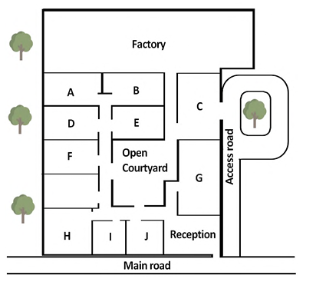

**15** coffee room ___

**16** warehouse ___

**17** staff canteen ___

**18** meeting room ___

**19** human resources ___

**20** boardroom ___

**Answers**

|  |  |
| --- | --- |
| 11 | C |
| 12 | A |
| 13 | B |
| 14 | C |
| 15 | H |
| 16 | C |
| 17 | G |
| 18 | B |
| 19 | I |
| 20 | A |

**Listening test - section 02 - Practise test 05**

**Questions 11 – 15**

Choose the correct letter, **A**, **B** or **C**.

**11**   Dartfield House school used to be

**A**   a tourist information centre.

**B**   a private home.

**C**   a local council building.

**12**   What is planned with regard to the lower school?

**A**   All buildings on the main site will be improved.

**B**   The lower school site will be used for new homes.

**C**   Additional school buildings will be constructed on the lower school site.

**13**   The catering has been changed because of

**A**   long queuing times.

**B**   changes to the school timetable.

**C**  dissatisfaction with the menus.

**14**   Parents are asked to

**A**   help their children to decide in advance which serving point to use.

**B**   make sure their children have enough money for food.

**C**   advise their children on healthy food to eat.

**15**   What does the speaker say about the existing canteen?

**A**   Food will still be served there.

**B**   Only staff will have access to it.

**C**   Pupils can take their food into it.

**Questions 16-18**

What comment does the speaker make about each of the following serving points in the Food Hall?

*Choose****THREE****answers from the box and write the correct letter,****A-D****, next to Questions 16-18.*

**Comments**

**A**  pupils help to plan menus

**B**  only vegetarian food

**C**  different food every week

**D**  daily change in menu

**Food available at serving points in Food Hall**

**16**   World Adventures …………

**17**   Street Life …………

**18**   Speedy Italian …………

**Questions 19 and 20**

Choose **TWO** letters, **A-E**.

Which **TWO** optional after-school lessons are new?

**A**  swimming

**B**  piano

**C**  acting

**D**  cycling

**E**  theatre sound and lighting

Answers

11   C

12   B

13   A

14   A

15   C

16   D

17   A

18   B

19&20   B, C

**Listening test - section 02 - Practise test 06**

Questions 11-20

Questions 11-13

Label the diagram below.

Choose **THREE** answers from the box and write the correct letter, **A-E**, next to questions **11-13.**

A electricity indicator

B on/off switch

C reset button

D time control

E warning indicator

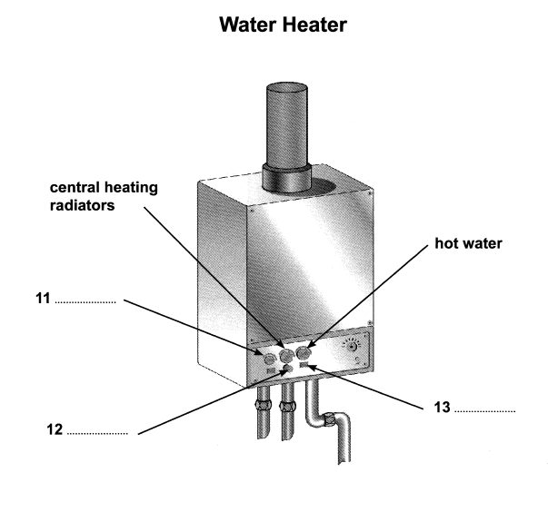

Questions 14-18

Where can each of the following items be found?

Choose **FIVE** answers from the box and write the correct letter, **A-G**, next to questions **14-18.**

**Locations**

**A** in box on washing machine

**B** in cupboard on landing

**C** in chest of drawers

**D** next to window in living room

**E** on shelf by back door

**F** on top of television

**G** under kitchen sink

14 pillows ……………….

15 washing powder ……………….

16 key ……………….

17 light bulbs ……………….

18 map ……………….

Questions 19 and 20

Complete the notes below.

Write **ONE WORD AND/OR A NUMBER** for each answer.

The best place to park in town - next to the station

Phone number for takeaway pizzas – 19 ……………….

Railway museum closed on 20 ……………….

Answers

|  |  |
| --- | --- |
| 11 | B |
| 12 | C |
| 13 | E |
| 14 | B |
| 15 | E |
| 16 | D |
| 17 | A |
| 18 | C |
| 19 | 732281 |
| 20 | thursday |

**Listening test - section 02 - Practise test 07**

Questions 11 – 14

*Choose the correct letter,***A, B***or***C.**

**11**   Many hotel managers are unaware that their staff often leave because of

**A**   a lack of training. **B**  long hours. **C**   low pay.

**12**   What is the impact of high staff turnover on managers?

**A**   an increased workload **B**   low morale **C**   an inability to meet targets

**13**   What mistake should managers always avoid?

**A**   failing to treat staff equally **B**   reorganising shifts without warning

**C**   neglecting to have enough staff during busy periods

**14**   What unexpected benefit did Dunwich Hotel notice after improving staff retention rates?

**A**   a fall in customer complaints **B**   an increase in loyalty club membership

**C**   a rise in spending per customer

Questions 15-20

Which way of reducing staff turnover was used in each of the following hotels?

*Write the correct letter,***A, B***or****C****, next to Questions 15-20.*

**Hotels**

**15** The Sun Club            ……………….

**16** The Portland            ……………….

**17** Bluewater Hotels     ……………….

**18** Pentlow Hotels         ……………….

**19** Green Planet             ……………….

**20** The Amesbury           ……………….

**Ways of reducing staff turnover**

**A**   improving relationships and teamwork

**B** offering incentives and financial benefits

**C**   providing career opportunities

|  |
| --- |
|  |

Answers

11   A

12   A

13   A

14   C

15   A

16   C

17   B

18   C

19   B

20   A

**Listening test - section 02 - Practise test 08**

Questions 11 and 12

Choose **TWO** letters, **A-E.**

According to Megan, what are the **TWO** main advantages of working in the agriculture and horticulture sectors?

**A** the active lifestyle

**B** the above-average salaries

**C** the flexible working opportunities

**D**  the opportunities for overseas travel

**E** the chance to be in a natural environment

Questions 13 and 14

Choose **TWO** letters, **A-E.**

Which **TWO** of the following are likely to be disadvantages for people working outdoors?

**A** the increasing risk of accidents

**B**  being in a very quiet location

**C** difficult weather conditions at times

**D** the cost of housing

**E** the level of physical fitness required

Questions 15-20

What information does Megan give about each of the following job opportunities?

Choose **SIX** answers from the box and write the correct letter, **A-H**, next to Questions **15-20.**

**Job opportunities**

**15** Fresh food commercial manager …………….

**16** Agronomist …………….

**17** Fresh produce buyer …………….

**18**  Garden centre sales manager …………….

**19** Tree technician …………….

**20** Farm worker …………….

**Information**

**A** not a permanent job

**B** involves leading a team

**C** experience not essential

**D** intensive work but also fun

**E**  chance to earn more through

overtime

**F** chance for rapid promotion

**G** accommodation available

**H** local travel involved

Answers

11&12   A, C

13&14   B, C

15   D

16   F

17   A

18   H

19   C

20   G

**Listening test - section 02 - Practise test 9**

Questions 11-14

Choose the correct letter, **A, B**or **C**.

Local council report on traffic and highways

**11**   A survey found people’s main concern about traffic in the area was

**A**   cuts to public transport.

**B**   poor maintenance of roads.

**C**   changes in the type of traffic.

**12**   Which change will shortly be made to the cycle path next to the river?

**A**   It will be widened.

**B**   It will be extended.

**C**  It will be resurfaced.

**13**   Plans for a pedestrian crossing have been postponed because

**A**   the Post Office has moved.

**B**   the proposed location is unsafe.

**C**   funding is not available at present.

**14**   On Station Road, notices have been erected

**A**   telling cyclists not to leave their bikes outside the station ticket office.

**B**  asking motorists to switch off engines when waiting at the level crossing.

**C**  warning pedestrians to leave enough time when crossing the railway line.

Questions 15-20

Label the map below.

*Write the correct letter,****A-I****, next to Questions 15-20.*

**Recreation ground after proposed changes**

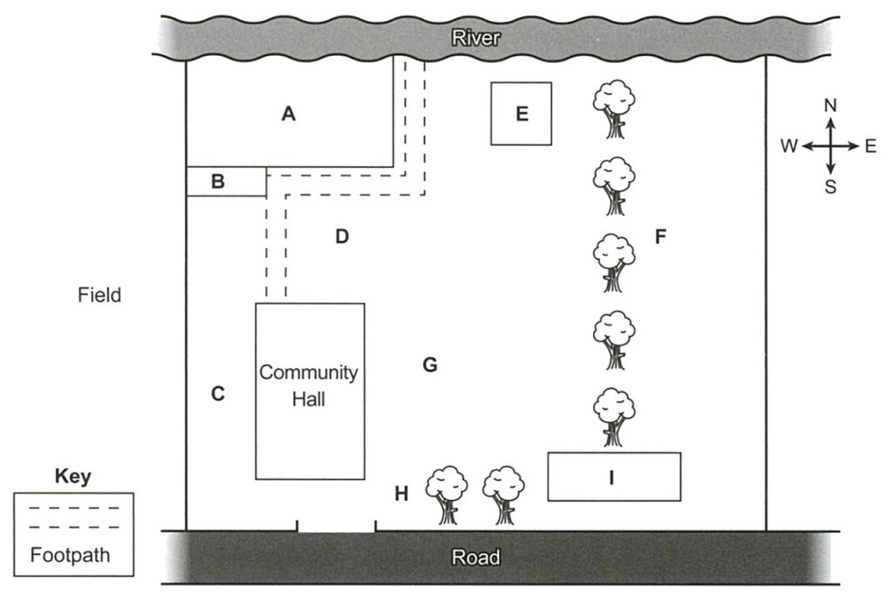

**15**  New car park                            ……………

**16** New cricket pitch                    ……………

**17**  Children’s playground            ……………

**18**   Skateboard ramp                     ……………

**19**   Pavilion                                      ……………

**20**  Notice board                            ……………

Answers

**11** C  
**12** A  
**13** B  
**14** B  
**15** C  
**16** F  
**17** A  
**18** I  
**19** E  
**20** H

**Listening test - section 02 - Practise test 10**

Questions 11 – 14

Choose the correct letter, **A, B** or **C**.

**Minster Park**

**11** The park was originally established

**A** as an amenity provided by the city council. **B** as land belonging to a private house.

**C** as a shared area set up by the local community.

**12** Why is there a statue of Diane Gosforth in the park?

**A** She was a resident who helped to lead a campaign.

**B** She was a council member responsible for giving the public access.

**C**  She was a senior worker at the park for many years.

**13** During the First World War, the park was mainly used for

**A** exercises by troops. **B** growing vegetables. **C** public meetings.

**14**  When did the physical transformation of the park begin?

**A** 2013 **B**  201 **C**  2016

Questions 15-20

Label the map below.

Write the correct letter, **A-I**, next to Questions 15-20.

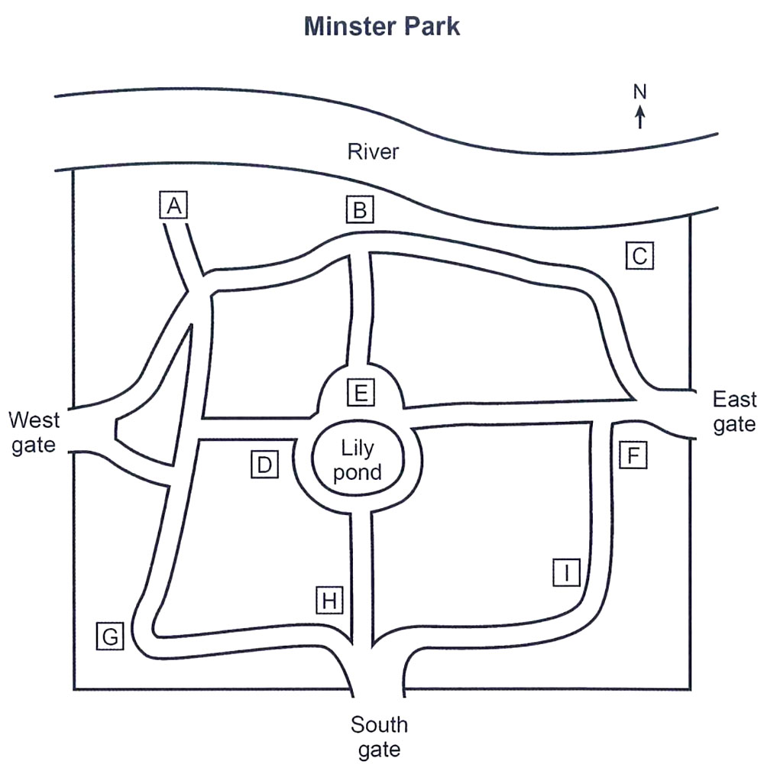

**15**  statue of Diane Gosforth …………..

**16** wooden sculptures …………..

**17** playground …………..

**18** maze …………..

**19** tennis courts …………..

**20** fitness area …………..

Answers

11. C  
12. A  
13. B  
14. C  
15. E  
16. C  
17. B  
18. A  
19. G  
20. D